*Things we don’t understand –

a) ask paul about choosing specific *m* values

b) why does suppressing positive replications increase precision

***tallies and each tally is subdivided by the various # of studies that led to that tally

###have this for true and false effects

1. Increasing the base rate of true hypotheses increases precision at low positive tallies

**Alpha = 0.05, base rate goes from small to large (top left to bottom right)**

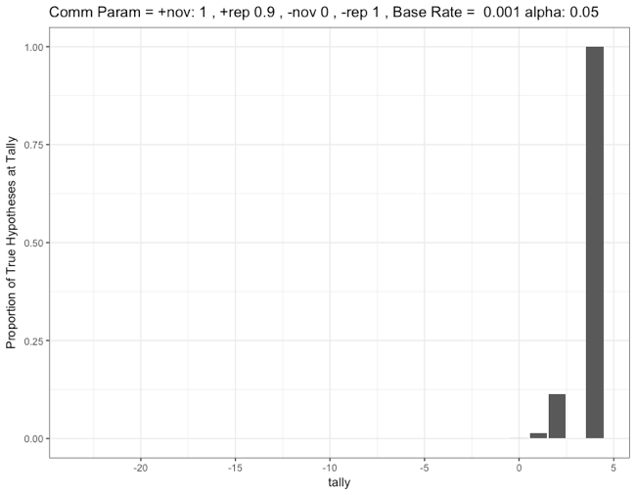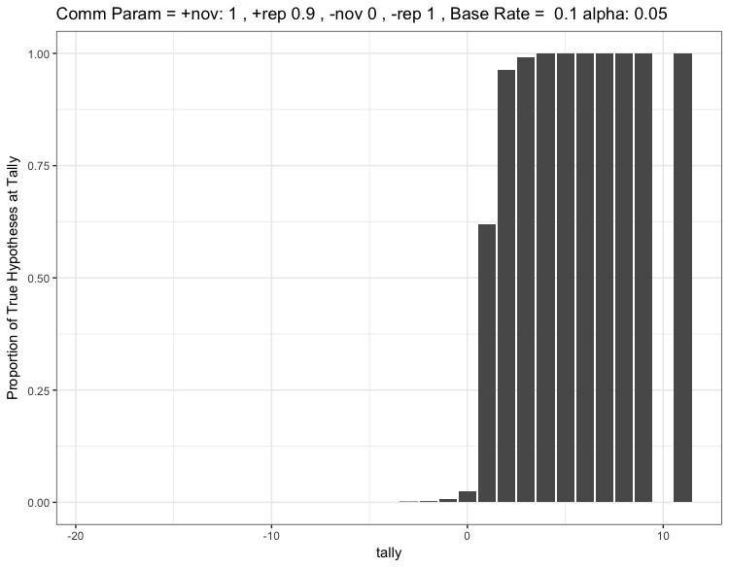

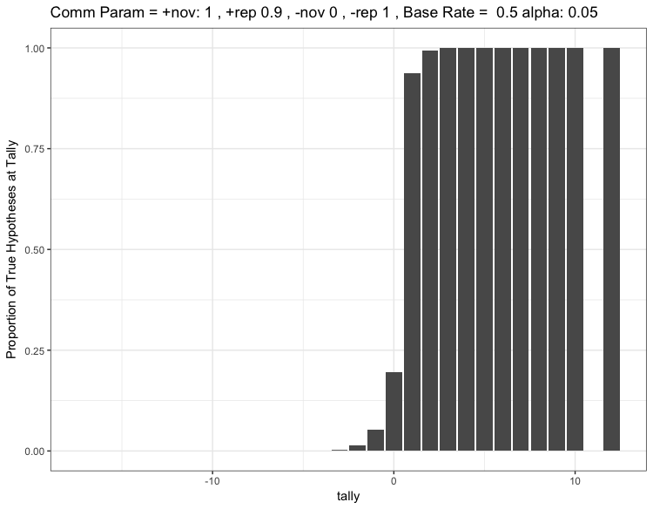

1. Increasing the false positive rate decreases the precision at low positive tallies (because lots of false hypotheses end up with positive tallies)

**Alpha = 0.4, base rate goes from small to large (top left to bottom right)**

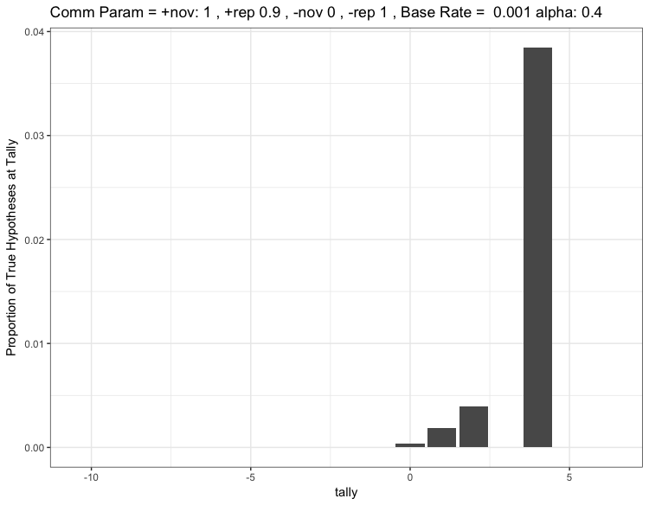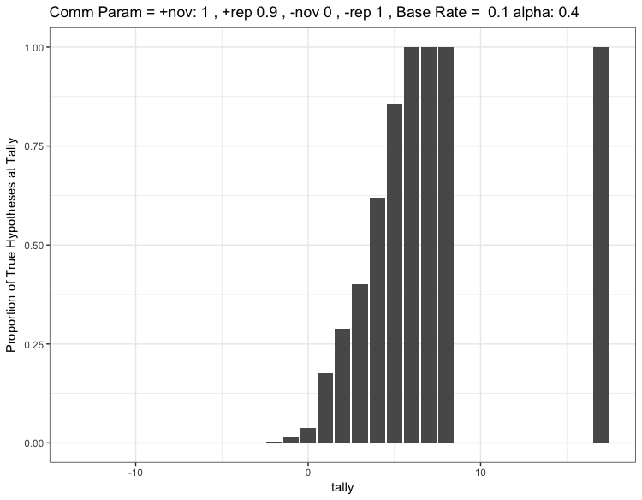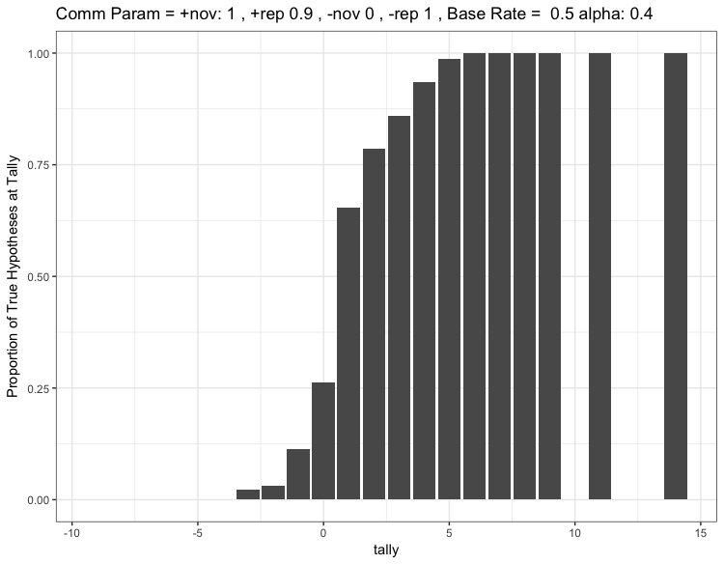

2a) compare precision for the same base rate, but when increasing false positive rate



1. Decreasing communication of positive replications results in a higher proportion of true hypotheses at low positive tallies



**However, it makes true and false hypotheses less likely to reach high tallies**







**How does the effect of suppressing communication depend on the base rate?**

**(for all these plots, p_novel is set at 0.6 - - - so, there is a 60% chance that any given study is novel and a 60% chance it is a replication)**

**Base rate 0.001**





**Base rate 0.1**





Distribution of hyp



